Secondary Sources

Definition
# Source: AI Source: Provided by: [Data Path: Persons Table -> ID Column: 1, Name_En Column: Motasem Essam] -> From: [Chatgpt (GPT‑5 Mini)] on [12/10/2025]
Secondary sources of data are sources where the data has already been collected, processed, or published by someone else, and is reused for another purpose.
Key idea:
You do not collect the data yourself — you use existing data.

Characteristics of Secondary Data
# Source: AI Source: Provided by: [Data Path: Persons Table -> ID Column: 1, Name_En Column: Motasem Essam] -> From: [Chatgpt (GPT‑5 Mini)] on [12/10/2025]
- Already collected by another person or organization
- Faster and cheaper to obtain
- May be less specific to your needs
- May be outdated or less accurate depending on the source

Common Sources of Secondary Data

1️⃣ Books and Academic Articles 📚
# Source: AI Source: Provided by: [Data Path: Persons Table -> ID Column: 1, Name_En Column: Motasem Essam] -> From: [Chatgpt (GPT‑5 Mini)] on [12/10/2025]
Definition:
Books, journals, and research papers written by experts that contain previously collected and analyzed data.
Example:
Using statistics about climate change from a scientific journal.

2️⃣ Government Reports and Statistics 🏛️
# Source: AI Source: Provided by: [Data Path: Persons Table -> ID Column: 1, Name_En Column: Motasem Essam] -> From: [Chatgpt (GPT‑5 Mini)] on [12/10/2025]
Definition:
Official data published by government agencies that provide national or regional statistics about population, economy, health, education, etc.
Example:
Population data from a national census.

3️⃣ Online Databases and Websites 🌐
# Source: AI Source: Provided by: [Data Path: Persons Table -> ID Column: 1, Name_En Column: Motasem Essam] -> From: [Chatgpt (GPT‑5 Mini)] on [12/10/2025]
Definition:
Digital platforms that store and provide access to large collections of data and information for public or professional use.
Example:
Economic or demographic data available on government or research websites.

4️⃣ Company Reports 🏢
# Source: AI Source: Provided by: [Data Path: Persons Table -> ID Column: 1, Name_En Column: Motasem Essam] -> From: [Chatgpt (GPT‑5 Mini)] on [12/10/2025]
Definition:
Documents published by organizations that include business data such as financial performance, sales statistics, and market analysis.
Example:
A company’s annual report showing yearly revenue and profit.

5️⃣ Historical Records / Archives 🗂️
# Source: AI Source: Provided by: [Data Path: Persons Table -> ID Column: 1, Name_En Column: Motasem Essam] -> From: [Chatgpt (GPT‑5 Mini)] on [12/10/2025]
Definition:
Collections of past documents, records, or datasets preserved for reference and research.
Example:
Old weather records used to study long-term climate trends.

Example
# Source: AI Source: Provided by: [Data Path: Persons Table -> ID Column: 1, Name_En Column: Motasem Essam] -> From: [Chatgpt (GPT‑5 Mini)] on [12/10/2025]
A student wants to study population growth in Egypt.
Instead of collecting data from every household, the student uses government census reports.

Year | Population
2010 | 82 million
2020 | 102 million
Because the data was already collected by the government, it is secondary data.

Primary vs Secondary Data
# Source: AI Source: Provided by: [Data Path: Persons Table -> ID Column: 1, Name_En Column: Motasem Essam] -> From: [Chatgpt (GPT‑5 Mini)] on [12/10/2025]
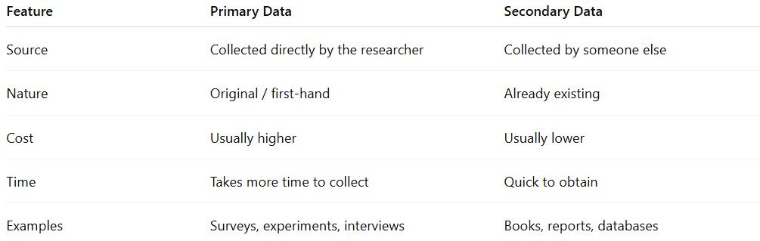
Feature | Primary Data | Secondary Data
Source | Collected directly by the researcher | Collected by someone else
Nature | Original / first-hand | Already existing
Cost | Usually higher | Usually lower
Time | Takes more time to collect | Quick to obtain
Examples | Surveys, experiments, interviews | Books, reports, databases

✅ Simple way to remember
# Source: AI Source: Provided by: [Data Path: Persons Table -> ID Column: 1, Name_En Column: Motasem Essam] -> From: [Chatgpt (GPT‑5 Mini)] on [12/10/2025]
- Primary data → You collect it yourself.
- Secondary data → Someone else collected it before.

